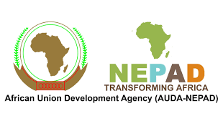
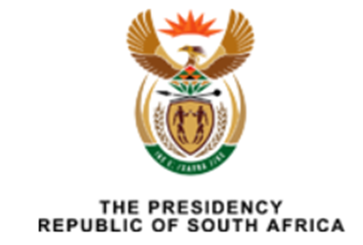
Presidential Infrastructure Champions Initiative (PICI) Report
2023

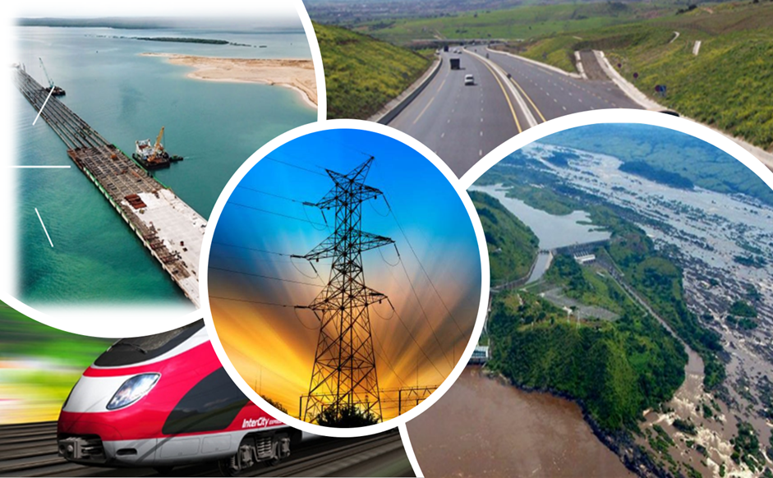

Contents

Abbreviations ii
Foreword (AUDA-NEPAD) iii
Foreword - Government of South Africa iii
Executive Summary v
1.0 Introduction 1
1.1 About PICI & Membership Status 1
1.2 PICI Impact - Overcoming Bottlenecks 6
1.3 PICI Impact - Advancing projects through Resource Mobilization 6
1.4 PICI Impact - Exchanging knowledge and sharing experiences. 6
1.5 PICI Impact – Project-specific coordination frameworks 7
2.0 Detailed Project Progress and Updates 7
ALGERIA - The Missing Links of the Trans-Sahara Highway 8
CONGO - Kinshasa-Brazzaville Bridge Road/Rail Project 10
COTE D’IVOIRE - The Abidjan-Lagos Highway Project 11
EGYPT - The Lake Victoria – Mediterranean Sea Navigational Line (VICMED) 12
KENYA - The Lamu Port - South Sudan – Ethiopia Transport Corridor (LAPSSET) Project 14
NAMIBIA – The Namibia-International Logistics Hub 16
NIGERIA - The Nigeria-Algeria Gas Pipeline Project (Trans-Sahara Gas Pipeline- TSGP) 18
RWANDA - Unblocking Political Bottlenecks for ICT Broadband and Optic Fibre Projects Linking Neighbouring Countries 19
SENEGAL - Dakar-Bamako (Dakar – Ndjamena – Djibouti) Corridor Project 21
SOUTH AFRICA - Lesotho Highlands Water Project – Phase II 23
SOUTH AFRICA - Grand Inga Project 25
SOUTH AFRICA - The Beitbridge Border post and related infrastructure 26
SOUTH AFRICA - South Africa to Become the Hub for the Manufacture and Supply of Rail Stock for Africa 29
SUDAN - Sawakin, Port Sudan Project and two related infrastructure Projects 31
3.0 Lessons Learned & Recommendations 32
4.0 Conclusion 34
Annex 1 - PICI Implementation Framework 35
Annex 2 -Countries Benefiting from PICI Projects 38

Abbreviations
AID | The African Infrastructure Database
AU | The African Union
AUDA-NEPAD | African Union Development Agency
BRICS | Brazil, Russia, India, China, and South Africa
HSGIC | Heads of State and Government Orientation Committee
ICT | Information and Communication Technology
PICI | Presidential Infrastructure Champions Initiative
PIDA | Programme for Infrastructure Development in Africa
REC | Regional Economic Community
SDM | Service Delivery Mechanism
TICAD | Tokyo International Conference on African Development
TTT | Technical Task Team

Foreword (AUDA-NEPAD)

Foreword - Government of South Africa

Executive Summary

The 2023 Progress Report of the Presidential Infrastructure Champions Initiative (PICI) highlights the significant progress amid hurdles faced in joint efforts towards regional infrastructure development in Africa. The PICI has been instrumental in spotlighting and fostering support for essential transnational projects across various sectors, including transport, energy, ICT, and transboundary water. During the reporting period of 2021 to 2023, notable progress has been achieved in several projects under PICI. Some of the examples of projects that have registered progress include the following:
- Trans-Sahara Highway: As of 2023, about 90% of the project was complete. The focus is currently on the Malian segment, with around 240 kilometres left to construct in Mali and an additional 140 kilometres in Algeria.
- Fibre Optic Link Between Algeria and Nigeria: The Algerian section of the optic fiber backbone, spanning 2700 kilometres, has been successfully completed and is fully operational.
- Nigeria-Algeria Gas Pipeline Project: In July 2022, the energy ministers of Algeria, Niger, and Nigeria signed a memorandum of understanding (MoU) to reinvigorate the project and update feasibility studies.
- Kinshasa-Brazzaville Bridge Road/Rail Project: Africa50 was mandated as the lead developer with the AfDB pledging US210 million of the total cost (estimated between US$550 - 660 million). The project is expected to be completed by 2028 and will serve 5 million passengers and 3 million tons of freight annually once completed.
- Abidjan-Lagos Highway Project: Through the AfDB, financing of US$25million contributed to the project’s preparation and preliminary studies. In 2022, at the Africa Investment Forum (AIF), the African Development Bank (AfDB) declared the mobilisation of USD 15.6 billion for the project and the first investor roundtable towards securing this financing was held in 2023.
- Smart Africa – 2023 marked 10 years since the launch of the initiative with significant results achieved in developing blueprints and mobilising partners and investors to develop ICT infrastructure and solutions.

It is important to note that due to challenges related to the availability and accessibility of data, the subsequent projects have been categorized according to their progress in 2020: The Sawakin Port Sudan Project, the Dakar-Bamako Road/Rail Project, the Kinshasa-Brazzaville Bridge Project, and the Trans-Sahara Optic Fibre Link connecting Algeria and Nigeria.
This report reveals that despite significant progress made on PICI projects, they continue to face challenges from the complex dynamics of overseeing extensive cross-border infrastructure endeavours in the face of fluctuating fiscal resources and geopolitical transformations. Midst the COVID-19 pandemic, several African nations experienced slow economic growth coupled with escalating debt. The consequences meant governments were unable to invest in important infrastructure projects due to limited budgetary resources. Moreover, economic disruptions caused by geopolitical instability and changes in Africa and around the world have redirected resources and focus from infrastructure development.
Notwithstanding these obstacles, Africa maintains its unwavering commitment to its development as outlined in Agenda 2063. PICI will persist in serving as an example of the potential for success when initiatives are actively spearheaded by African leaders.

Introduction
The Presidential Infrastructure Champions Initiative (PICI) was initiated by the Government of South Africa in 2011, with the aim of expediting the implementation of critical regional infrastructure projects in Africa through the active involvement of African leaders.
PICI’s main goal is to address Africa’s infrastructure deficit and stimulate regional infrastructure development by offering a unique platform for African Heads of State and Government to actively contribute to the planning and implementation of essential infrastructure projects. The Initiative provides strategic direction and promotes collaboration between countries to ensure the successful advancement of selected projects. Through PICI, African leaders have showcased their capacity to steer key infrastructure projects, thereby making a substantial contribution to the continent’s integration and global connectivity.
This report presents a summary of the notable advancements in Africa's infrastructure development under PICI during the reporting period from 2021 to 2023. It provides an overview of the initiative and elaborates on the significant achievements accomplished this far. Furthermore, the report provides valuable updates on each of the ongoing projects within the PICI portfolio. Lastly, the report concludes by sharing insightful recommendations to further enhance the effectiveness and impact of the Initiative.

About PICI & Membership Status

The initiative aims to accelerate regional infrastructure development in Africa through the active involvement of African Heads of State and Government in the development and implementation of projects. The PICI was jointly conceptualized by AUDA-NEPAD (African Union Development Agency - New Partnership for Africa's Development) and the South African Presidency. The main objective of PICI is to promote regional integration and trade by focusing on the development of transboundary infrastructure projects in various sectors, including transport, energy, information, and communication technology (ICT), and transboundary water. PICI projects are selected based on specific criteria, including being regional or continental in nature, being bankable and beyond the pre-feasibility or feasibility stages, and having quantifiable socio-economic benefits that promote regional integration and trade in the short to medium term.

Each country’s President or Head of State champions specific projects from four key economic development sectors namely in the energy, ICT, transport, and water sectors. Projects are selected based on their potential to stimulate economic growth, promote regional integration, and improve the quality of life for African citizens. Currently, most of the projects are part of the Programme for Infrastructure Development in Africa (PIDA) portfolio and the initiative fosters collaboration and coordination among the participating countries.

As of 2023, the initiative had 12 participating countries - Algeria, Benin, Congo, Côte d’Ivoire, Egypt, Namibia, Nigeria, Kenya, Rwanda, Senegal, South Africa, and Sudan as illustrated below. The map below illustrates the geographical distribution of these participating countries:
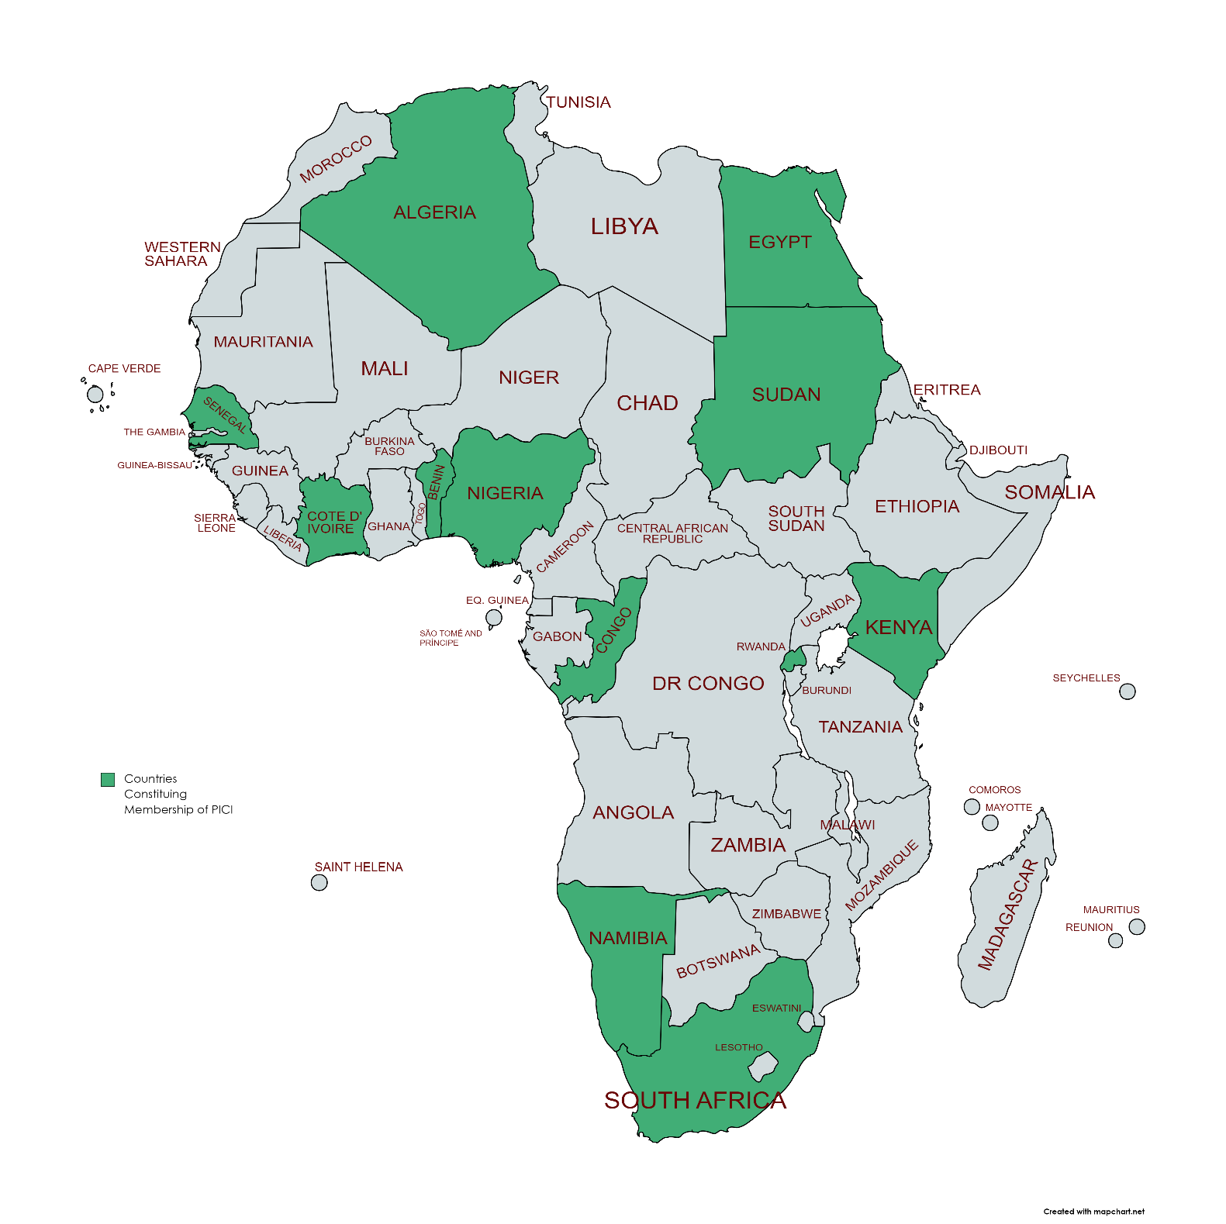
Figure 1: Geographical Distribution of Participating Countries
The PICI has undergone growth and development since its inception, with additional member countries joining the initiative over the eleven years. The evolution of PICI has seen its membership grow from 8 countries in 2011 to 12 countries in 2020, with ongoing efforts to address transboundary infrastructure challenges and foster collaboration among member states. The expansion of PICI over the years has been illustrated below:

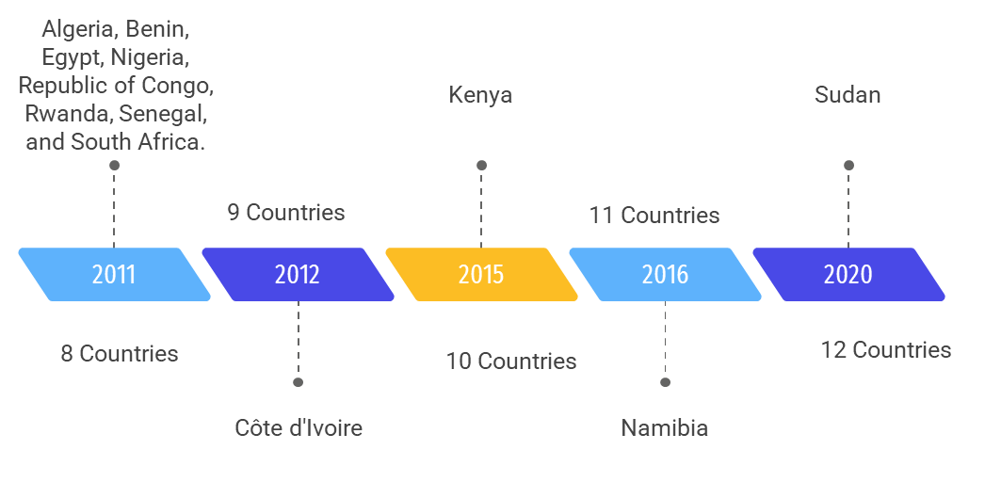
Figure 2 Evolution of PICI Membership

PICI represents a portfolio of infrastructure initiatives that have been identified as priority projects for the development and integration of the African continent. These projects, along with others in the PIDA portfolio, have been identified as critical for addressing infrastructure gaps, promoting regional integration, and fostering economic development in Africa. However, it is important to note that the list of projects may evolve over time as new initiatives are identified and existing projects are completed or modified. The following constitutes the list of PICI projects and respective project champions:

Table 1 List of PICI Projects and Champions

Country | Head of State | Project | Sub-components
Algeria | H.E President Abdelmadjid Tebboune | Trans-Sahara Highway Missing links and the Optic Fibre Link between Algeria and Nigeria. | Trans-Sahara Highway Missing links
 |  |  | Trans-Sahara Optic Fibre Link between Algeria and Nigeria.
Congo | H.E President Denis Sassou Nguesso | Kinshasa-Brazzaville Bridge Project. | The bridge/road component  The design, construction and operation of a railway line connecting Kinshasa and Brazzaville and linking with the existing Lubumbashi-Ilebo line.
Cote d’Ivoire | H.E President Alassane Ouattara | Abidjan-Lagos Corridor Project. | Corridor's infrastructure project management and coordination.  Corridor performance monitoring.  Trade facilitation  Improvement of the road  HIV/AIDS programs.
Egypt | H.E President Abdel Fattah el-Sisi | Navigational Line between Lake Victoria and the Mediterranean Sea (VICMED). | Constructing a navigational line connecting Lake Victoria and the Mediterranean Sea through the Nile River.  Supporting economic development in the Nile Basin by raising the level of trade and transport of goods and people.  Establishing river navigation management training centres in some of the footprint states based on the Egyptian experience.
Kenya | H.E President William Ruto | LAPSSET Corridor Project. | Lamu Port (32 Berth, Deep Sea Port at Manda bay, Lamu County).  Highways (from Lamu to Isiolo, Isiolo to Juba, Isiolo to Addis Ababa, and Lamu to Garsen).  Two oil Pipelines (from Lamu to Isiolo, to Juba & from Lamu to, Isiolo to Addis Ababa).  Interregional Standard Gauge Railway lines (Lamu to Isiolo, Isiolo to Juba, Isiolo to Addis Ababa, and Nairobi to Isiolo).  Three International airports (Lamu, Isiolo, and Lake Turkana).  Three resort cities (Lamu, Isiolo and Lake Turkana).
Namibia | H.E President Hage Geingob | Namibia-International Logistics Hub | Grootfontein/Rundu/Katima Mulilo Railway Line (Trans-Caprivi Corridor).  Trans-Kalahari Railway (TKR).  Trans Orange Corridor- Port of Luderitz.  Baynes Hydro Power Project.
Nigeria | H.E President Bola Ahmed Tinubu | Trans-Sahara Gas Pipeline. | 1 037 km from Nigeria to the Niger border.  841 km from Niger to Algeria  2 303 km across Algeria.  220 km from Algeria to Spain
Rwanda | H.E President Paul Kagame | Unblocking Political Bottlenecks for ICT Broadband and Smart Africa Initiative | The ICT Broadband and Optic Fibre Project for EAC countries.
 |  |  | The Smart Africa initiative
Senegal | H.E President Macky Sall | Dakar-Bamako Road/Rail Project. | The road component comprises the construction/renovation of the road between Dakar and Djibouti  The railway component entails the construction of a new railway network with standard gauge
South Africa | H.E President Cyril Ramaphosa | The North-South Road, Rail and related Infrastructure Corridor | South Africa to become the hub for the manufacture and supply of Rail Stock for Africa.
 |  |  | The Beitbridge Border Post and related infrastructure; connecting South Africa and Zimbabwe
 |  |  | The Grand Inga Hydropower Project (Inga 3)
 |  |  | The Lesotho Highlands Water Project - Phase II (LHWP); South Africa and Lesotho
Sudan |  | The Sawakin, Port Sudan Project and two related Projects. | The Sawakin Seaport Harbour.  The Dakar-N'djamena-Port Sudan Railway.  The Babanusa - South Sudan Railway.

The portfolio of projects under PICI Projects is expected to benefit 29 African countries through its strategic focus on transnational infrastructure projects, aiming to enhance regional connectivity and foster economic growth across the African continent. The PICI projects are designed to benefit not only the initiative’s members but also other countries within the African continent as illustrated in the distribution of PICI projects across African countries below:
Figure 3: Distribution of PICI Projects Across the continent

A list of countries benefiting from PICI projects can be further be reviewed on Annex 2.

The initiative operates within a well-defined framework to ensure efficient coordination, progress monitoring, and overall effectiveness. It encourages collaboration among stakeholders and systematically monitors and reports project advancements to the African Union. Further details on PICI’s structure and governance frameworks can be found in the Annex 1.

PICI Impact - Overcoming Bottlenecks
The Presidential Infrastructure Champion Initiative (PICI) has been instrumental in resolving obstacles that impede project progress. Through political influence and stakeholder engagement, PICI has addressed regulatory issues, funding barriers, and other challenges. A notable achievement is the unblocking of regulatory obstacles in the implementation of “roam like home” in the East Africa region, an initiative championed by Rwanda which is now expanding to other regions.

PICI Impact - Advancing projects through Resource Mobilization
The PICI has been instrumental in mobilizing resources and attracting investments for infrastructure development. Through strategic partnerships and engagement with development financing institutions and private investors, PICI projects have secured funding for project implementation. Notable examples include the USD 15.6 billion mobilised for the Abidjan-Lagos Highway, USD 2 million for the VICMED Project and various funding agreements and partnerships under the Smart Africa initiative.
To improve the bankability of some PICI projects, AUDA-NEPAD has deployed its Service Delivery Mechanism (SDM) to provide technical assistance for early-stage project preparation.
AUDA-NEPAD continues to engage with a wide range of development partners and financiers to raise more funds and expand the private sector engagement in the PICI implementation process. These include, among others, the EU, World Bank. African Financial Corporation (AFC), African Development Bank (AfDB), Africa 50, and the Development Bank of Southern Africa (DBSA)

PICI Impact - Exchanging knowledge and sharing experiences.
PICI has enhanced infrastructure development strategies across the continent by facilitating knowledge sharing and disseminating lessons from project experiences.
To foster peer learning and knowledge exchange, PICI has established “strategic reflection meetings which provide a platform for stakeholders to discuss project progress, challenges, and potential improvements. The inaugural reflection session was conducted on July 14th, 2021. The subsequent session coincided with the 7th PIDA Week, held from February 28th to March 4th, 2022, in Nairobi, Kenya

PICI Impact – Project-specific coordination frameworks
Several PICI projects have established steering and coordination mechanisms to fast-track implementation:
- Abidjan-Lagos Corridor - The 19th Technical Experts and Ministerial Steering Committee Meeting on the Abidjan-Lagos Corridor Highway Development was held in Ghana in May 2023
- The Trans-Sahara Highway is steered by the Liaison Committee of the Trans Saharan Road (CLRT) which meets at senior official and ministerial level. The 75th Ministerial Sessions of the Liaison Committee of the Trans Saharan Road (CLRT) were held in June 2023 LAPSSET - The 3rd Meeting of LAPSSET Corridor Council of Ministers was held in Juba, South Sudan, in May 2023, where commitments to fast track the project were adopted. VICMED – at the regional level there is a Project Steering Committee (SC) comprised of two members from each participating country (one from the transport sector, the other from the water sector) while at national level National Committees that include major project stakeholders have been established.
- Grand Inga – DRC and South Africa established a Bi-National Commission, and the 12th Session of the Commission was held in July 202 where both countries re-affirmed their commitment to accelerate implementation of the project.
- Lesotho Highlands Water - South Africa and Lesotho coordinate implementation through the Lesotho Highlands Water Commission (LHWC)

Detailed Project Progress and Updates

The PICI project portfolio consists of a mix of projects aimed at addressing Africa's infrastructure needs and promoting regional integration. They are strategically selected to contribute to the development goals of the continent. In the pages that follow, detailed information on the projects and their progress and status are provided. The projects are presented in alphabetical order of the championing member state.

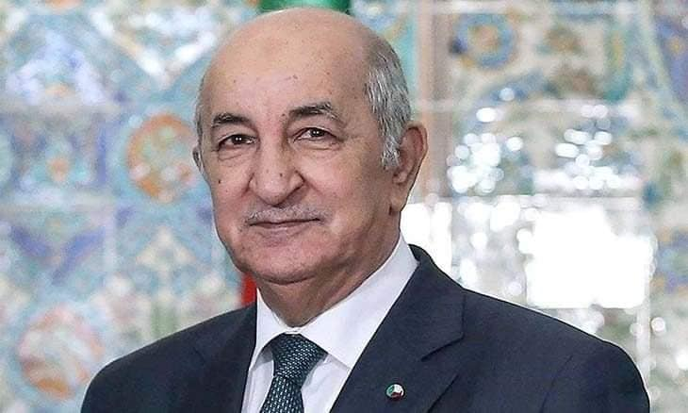
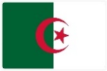
ALGERIA - The Missing Links of the Trans-Sahara Highway
Championed by Algeria, the project’s aim is to build a comprehensive road network that connects various countries in the Sahel region. It concentrates on finishing the remaining parts of the Trans-Sahara Highway, which runs through Algeria, Niger, Nigeria, Tunisia, Mali, and Chad. The project will improve regional connectivity, trade and transportation, and economic growth in the region.
H.E. President Abdelmadjid Tebboune,
Republic of Algeria

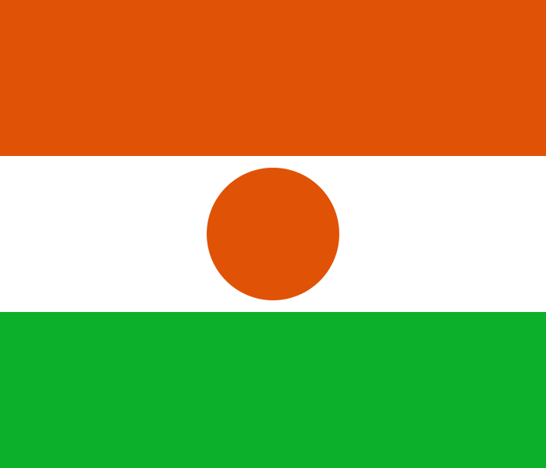  Niger |   Nigeria | 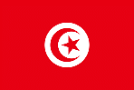  Tunisia |   Mali |   Chad
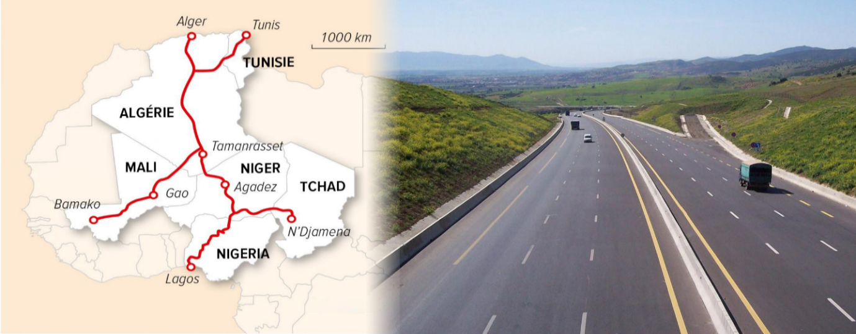
Project Status
As of 2023, the Trans-Saharan Road project, covering approximately 10,000 kilometres, has made remarkable progress, nearing 90% physical completion. Currently, the project's focus lies on the Malian segment, with around 240 kilometres left to construct in Mali and an additional 140 kilometres in Algeria. The missing links in Niger and Chad are expected to be completed by end of 2024.
Project Highlights
 |  | 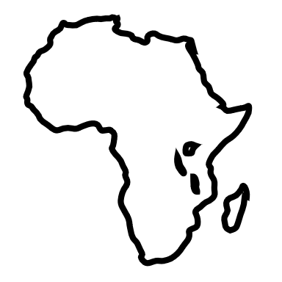
10,000 KM of Road to be Constructed. | 300 million People to Benefit from Road Network | 380 KM remaining to complete project
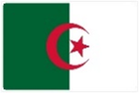
ALGERIA - Fibre Optic Link Between Algeria and Nigeria Via Niger
The Trans-Saharan Optic Fibre Broadband Project is a major initiative to connect Algeria, Niger, and Nigeria with a 4,500 km fibre optic cable network along the Trans-Sahara Gas Pipeline. The project will boost internet access and speed in these countries and link them to the global market.
H.E. President Abdelmadjid Tebboune,
The Republic of Algeria

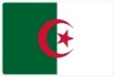  Algeria | Niger | Nigeria

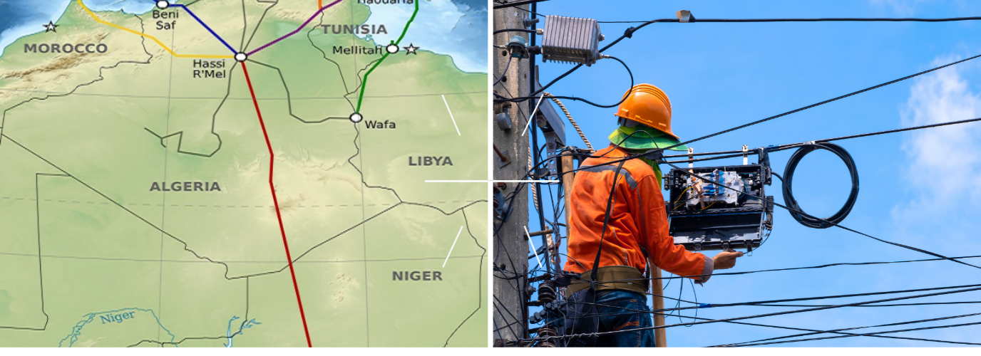
Project Status
According to updates from 2020, the project has achieved a significant milestone by completing and operating the Algerian section of the network, which is part of the national optic Fibre backbone covering 2700 km. The project plans to further improve and protect this section to ensure uninterrupted connectivity.

Project Highlights

4,500 KM of terrestrial optic fibre to be constructed. | 2,700 KM of fibre backbone Constructed. | 3 Countries to benefit from project upon completion


CONGO - Kinshasa-Brazzaville Bridge Road/Rail Project
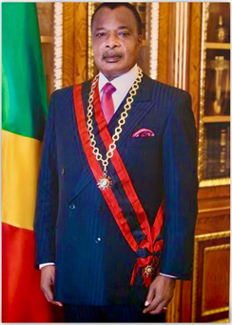
Championed by the Republic of Congo, the Kinshasa-Brazzaville Bridge Road/Rail Project is a significant infrastructure initiative aimed at constructing a fixed crossing that will link the cities of Kinshasa in the Democratic Republic of Congo (DRC) and Brazzaville in the Republic of Congo. This project will ensure continuity in railway and road traffic, facilitating transportation and promoting regional integration in Central, Eastern, and Southern Africa. The project consists of two main components: the bridge/road component and the design, construction, and operation of a railway line connecting Kinshasa and Brazzaville, which will link with the existing Lubumbashi-Ilebo line.
H.E. President Denis Sassou Nguesso,
The Republic of the Congo

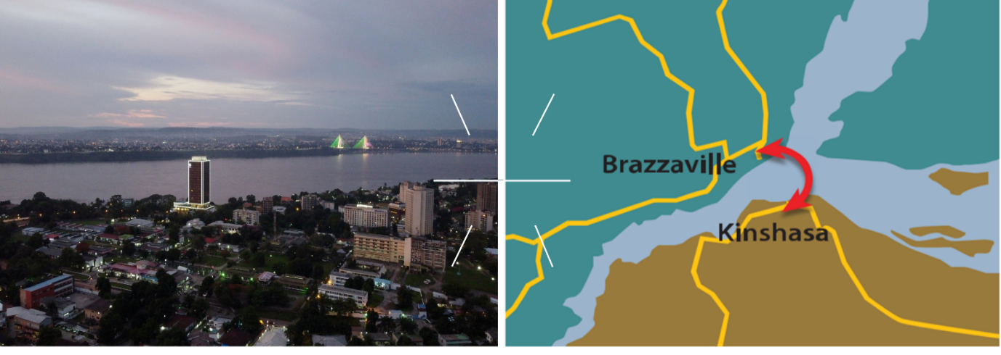  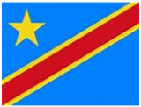  DRC | Congo Brazzaville

Project Status
According to 2020 updates, the project is expected to cater to an estimated 750,000 people and 340,000 tons of freight per year, with traffic projected to increase to more than 3 million people and 2 million tons of freight by 2025. The project is being developed as a Public-Private Partnership (PPP) and is a collaboration between the African Development Bank (AfDB), Africa50, and the governments of DRC and the Republic of Congo. Project expected to be completed in 2028
Project Highlights
 |  |  | 
1575 m of toll Bridge to be Constructed. | 3 M people to benefit from the project | 2 Countries to benefit from project upon completion | USD 550 million is the estimated cost of project


COTE D’IVOIRE - The Abidjan-Lagos Highway Project
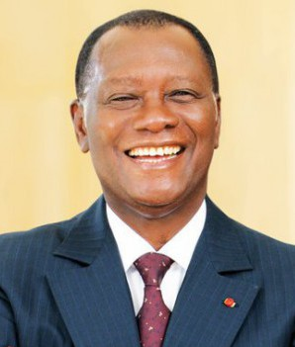
The Abidjan-Lagos Highway Project aims to construct a six-lane dual-carriage highway connecting the cities of Abidjan in Côte d'Ivoire and Lagos in Nigeria while traversing through Ghana (Accra), Togo (Lomé), and Benin (Cotonou). The project covers approximately 1,080 kilometres and is a flagship program of the Economic Community of West African States (ECOWAS).

H.E. President Alassane Quattara, The Republic of Cote d’Ivoire
 |   Côte d'Ivoire |   Ghana |   Togo |   Benin | Nigeria
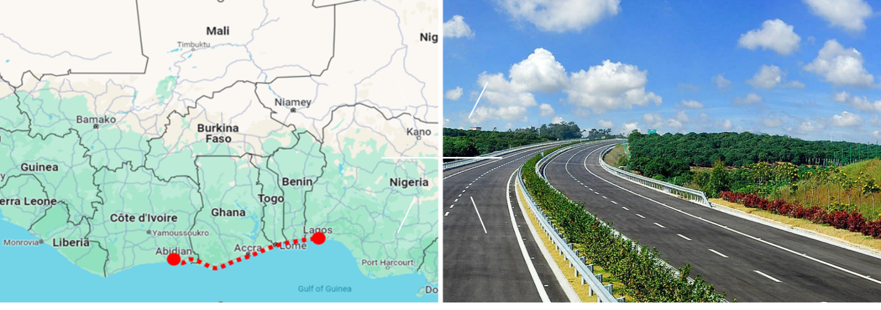
Project Status
An investors’ round table was organized by the African Development Bank (AfDB) and the ECOWAS Commission on September 26, 2023, at the AfDB headquarters. The primary objective of this event was to provide the latest project information to regional and international development finance institutions in order to secure the US$15.6bn required for construction. The round table was successful, attracting over 180 participants from more than 30 development partners. The project is planned for completion by 2030.
Project highlights
1,083 KM of Road to be Constructed. | 300 million People to Benefit from Project.


EGYPT - The Lake Victoria – Mediterranean Sea Navigational Line (VICMED)

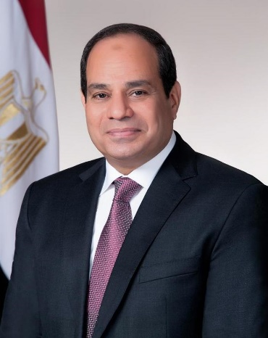
The project aims at establishing a navigational line connecting Lake Victoria, located in East Africa, to the Mediterranean Sea. The project will enhance trade, tourism, and economic development in the region, while also providing a cheaper and sustainable integrated multimodal transport alternative. The VICMED project has strategic objectives that include achieving socio-economic integration and cohesion, supporting economic development, and enhancing regional integration. It aims to connect footprint countries, provide opportunities for landlocked countries, and reinforce the region's position within the global economic system.
H.E. President Abdel Fattah Saeed Hussein Khalil el-Sisi
The Arab Republic of Egypt


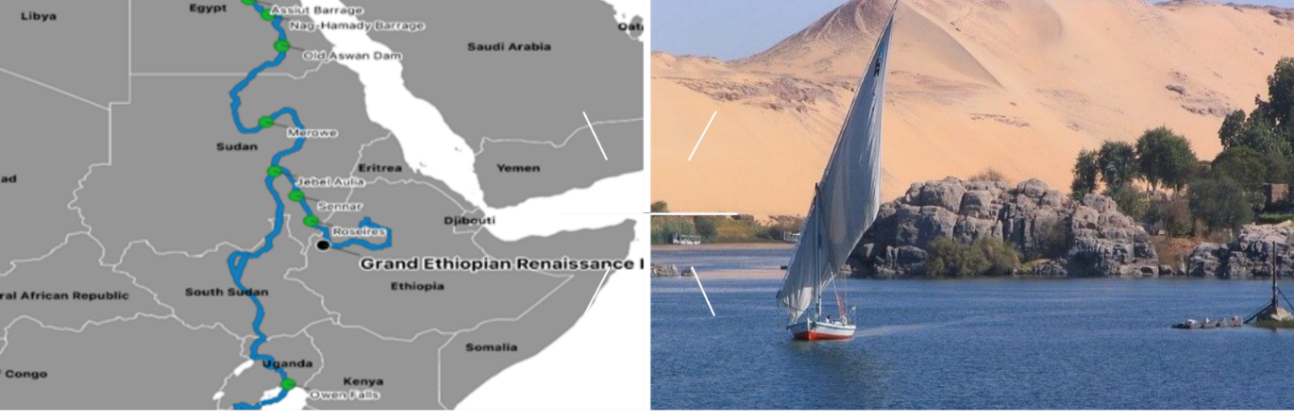



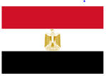 |  | 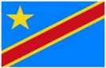 |  |  | 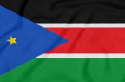
Project Status

The project is on track and in December 2022, the Phase 2 feasibility study was officially launched. The VICMED PMU has been working closely with AfDB, NEPAD-IPPF, and COMESA to secure $11.7 million for the study. The Terms of Reference for the study have been completed. The project faces the following challenges;
- Urgent need to secure funds for implementing the Feasibility studies Phase 2 – Part 1 and establishment and operation of Regional Operation Units in order not to lose the gained momentum for the project and to ensure ownership of the Countries.
- Need for more involvement in the project at the National level within the Countries (National Committees).
- Lack of data and information.
- Need to reinforce technical and institutional capacities in the field of IWT in the Nile Basin

Project Highlights

$11.7 m secured for feasibility study | 450 million People to Benefit from Project. | 10 Countries to benefit from

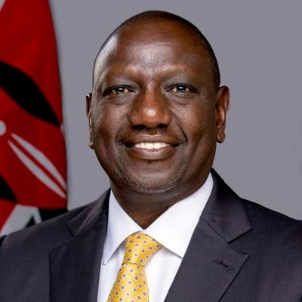

KENYA - The Lamu Port - South Sudan – Ethiopia Transport Corridor (LAPSSET) Project
This project aims to establish a transport infrastructure and economic corridor connecting Kenya to South Sudan and Ethiopia. The corridor covers seven counties in Kenya, namely Lamu, Garissa, Isiolo, Meru, Samburu, Turkana, and Marsabit.The LAPSSET Corridor Project was commissioned on March 2, 2012, by the Heads of State for Kenya, Ethiopia, and South Sudan. The project consists of various core infrastructure projects within a 500-meter-wide inner corridor. These include the construction of highways and railways, crude and product oil pipelines, and fiber optic cables. The elevation of LAPSSET to the Presidential Infrastructure Champion Initiative (PICI) in June 2015 has attracted significant interest from major development partners and investors, further enhancing its visibility and potential for economic growth.
H.E. President William Ruto,
The Republic of Kenya
  Kenya |   Ethiopia | 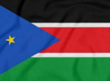  South Sudan
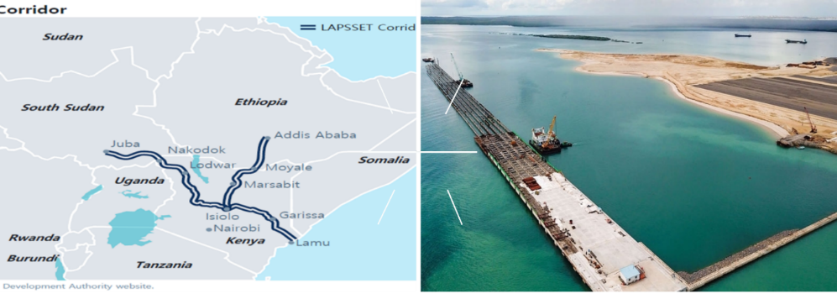

Project Status
Significant advancements have been achieved in the and noteworthy is the progress made with the Lamu Port, as it successfully accommodated its first ship at Berth One in 2021. The implementation of essential operational systems, such as information and communication technology (ICT) and cargo-handling equipment, has been completed to ensure the smooth unloading of goods from vessels.
The project faced the following challenges.
- Most of the sub-projects are at Project preparatory stage such as Feasibility studies, detailed engineering design studies due to lack of funding.
- Absence of a regional coordination mechanism making it difficult for the harmonious implementation in the three-foot print countries
- Unresolved Nakodok Border boundary dispute.

Project Impact / highlights

2,000 KM of SGR | 160 million People to Benefit from Project. | 3 Countries to benefit from project upon completion

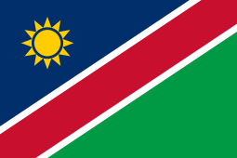
NAMIBIA – The Namibia-International Logistics Hub


Championed by Namibia, the project aims to enhance Namibia's position as a key player in regional trade and logistics, attracting investment and promoting economic growth. The Project comprises of four sub-projects namely a) Grootfontein/Rundu/Katima Mulilo Railway Line (Trans-Caprivi Corridor), b) the Trans-Kalahari Railway (TKR) c) the Trans Orange Corridor- Port of Luderitz and d) the Baynes Hydro Power Project.

The Namibia International Logistics Hub Construction Promotion Project Phase 2 is currently underway, and it is being funded by the Japanese International Cooperation Agency (JICA). JICA has extended around 319 million Yen (equivalent to around $3 million) for the project. The project involves the development of the Logistics Hub Centre (LHC) in Walvis Bay, Namibia. The LHC will serve as a strategic location for logistics companies, providing them with state-of-the-art infrastructure and facilities to support their operations. The goal is to contract more than 80% of the lots in the LHC by 2025.
H.E. President Hage Gottfried Geingob
The Republic of Namibia

Project Status
By 2020, a significant achievement in this project was the initiation, restoration, and enhancement of the railway line linking Walvis Bay and Arandis. The first phase of the project work plan was successfully completed in 2019, and phase two, funded by JICA, was projected to be finalized by July 2023. By 2025, the project is expected to be fully operational, making notable progress towards the realization of Namibia's goal as a prominent regional transportation and logistics hub. The major milestone for the subprojects achieved are;
- Grootfontein/Rundu/Katima Mulilo Railway Line (Trans-Caprivi Corridor).
- Trans-Kalahari Railway (TKR).
- Trans Orange Corridor- Port of Luderitz.
- Baynes Hydro Power Project
Editorial note - please note that the section will be updated with progress updates from the member state once they have been received.
Project Highlights
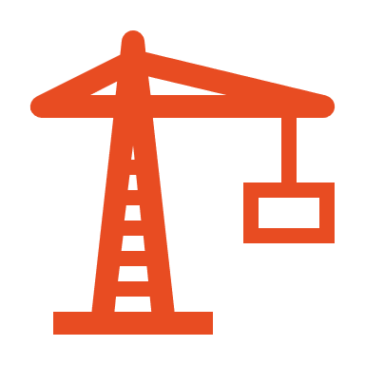
 | 2.5 million People to Benefit from Project. | 1 Country to benefit from project upon completion

NIGERIA - The Nigeria-Algeria Gas Pipeline Project (Trans-Sahara Gas Pipeline- TSGP)
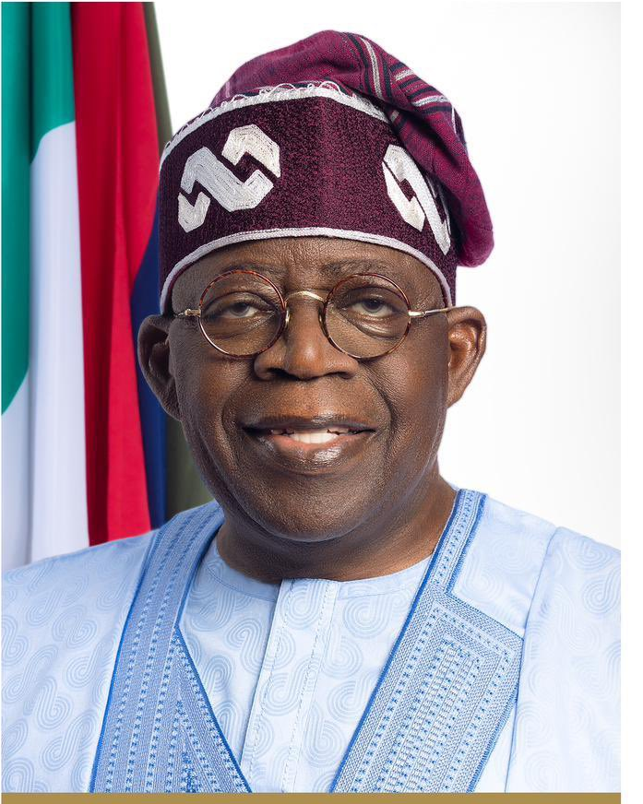
Championed by Nigeria, the project’s goal is to create a gas pipeline that links Nigeria and Algeria through Niger, boosting collaboration and integration among the neighbours. The pipeline can carry 30 billion cubic litres of natural gas per year.
H.E. President Bola Ahmed Tinubu
The Federal Republic of Nigeria
  Nigeria | Niger
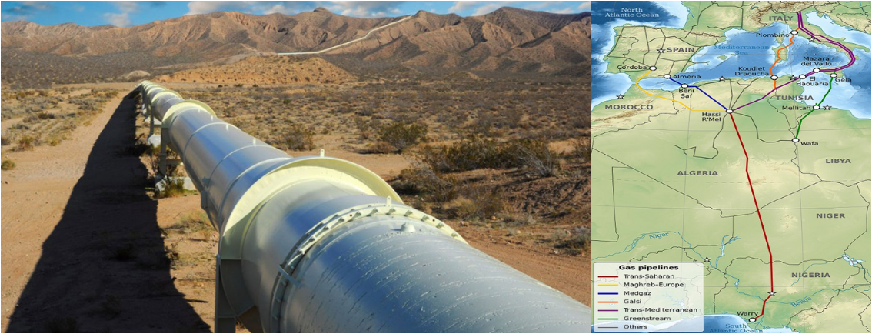
Project Status

According to 2022 updates, the project has made significant progress since July 2022, when the energy ministers of the three countries signed an MoU to revive and update the feasibility studies. They have also developed a comprehensive roadmap, set up a task force, and assigned an entity to oversee the feasibility study update. These actions show their strong dedication to this important endeavour. The project will span from Nigeria’s Warri region to Algeria’s Hassi R’Mel

Project Highlights
 |  |  | 
Annual Capacity of 30 billion Cubic Litres |  | 3 Countries to benefit from project upon completion


RWANDA - Unblocking Political Bottlenecks for ICT Broadband and Optic Fibre Projects Linking Neighbouring Countries
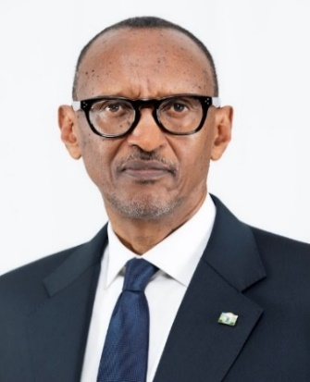
The "One Africa Network" project aims to eliminate roaming barriers among participating countries, making telecom services more affordable for African citizens, and keeping traffic within the continent. This initiative adopts a "Roaming Like at Home" approach, with harmonized guidelines.
H.E. President Paul Kagame
The Republic of Rwanda
The Smart Africa Initiative is driving several impactful projects to enhance telecommunications and connectivity across the continent.

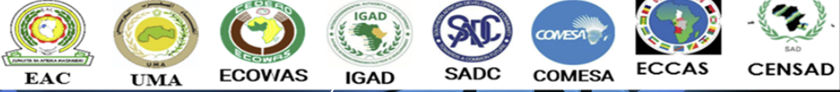

Project Status –
The ICT Broadband and Optic Fibre Project for all EAC countries have been duly completed, and all countries involved have been interconnected and linked to the submarine optic fibre cables from Mombasa and Dar es Salaam.

The EAC has put in place the relevant regulatory frameworks for the One Network Area (ONA) to pave the way for “Roam like at Home” services for mobile consumers. ONA places a cap on inter-state traffic tariffs and eliminates mobile roaming fees.

Adopted by the Council of African Regulators and the Council of ICT Ministers. A feasibility study is underway to harmonize policies, pricing models, and technical solutions for a pilot project, leveraging existing regional initiatives.

In 2013 President Paul Kagame initiated the Smart Africa Initiative which has a membership of 39 African countries known as the Smart Africa Alliance. The Initiative aims to harness information and communication technology (ICT) to foster economic development, enhance connectivity, and improve the quality of life for the people of Africa.

The Smart Africa Initiative is driving several impactful projects to enhance telecommunications and connectivity across the continent. Among the achievements of the Smart Africa Initiative is the Smart Africa Digital Academy (SADA), which is a capacity-building and skills development initiative to empower African citizens to reap the benefits of digital transformation.

Smart Africa is supporting the implementation of Digital Terrestrial Television (DTT), although only seven countries have completed the migration to DTT. Some challenges faced in the implementation are lack of infrastructure in rural areas, cost of migration, set-top box availability and affordability, and lack of digital content production.

Project Highlights
 |  |  | 
No infomation on the number of KM of fibre optic laid in this project. | 490,266,418 People to Benefit from Project. | All Countries in the EAC region are now fully connected. | A substantial amount running into millions of dollars was used


SENEGAL - Dakar-Bamako (Dakar – Ndjamena – Djibouti) Corridor Project
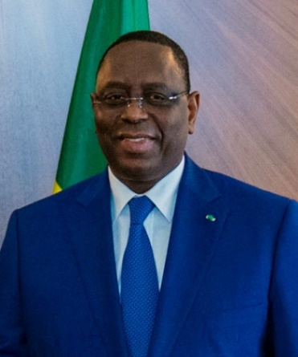
This project aims to enhance transportation infrastructure and connectivity along the corridor that spans from Dakar, Senegal, to Bamako, Mali, and further extends to Ndjamena, Chad, and Djibouti. The project encompasses both road and railway components, with the construction/renovation of the road between Dakar and Djibouti and the establishment of a new railway network with standard gauge. The Dakar-Bamako Corridor Project is part of the larger Program for Infrastructure Development in Africa (PIDA), which seeks to promote regional integration and economic development through the development of key infrastructure projects across the continent.
H.E. President Macky Sally
The Republic of Senegal

 |    |   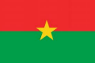 | 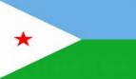

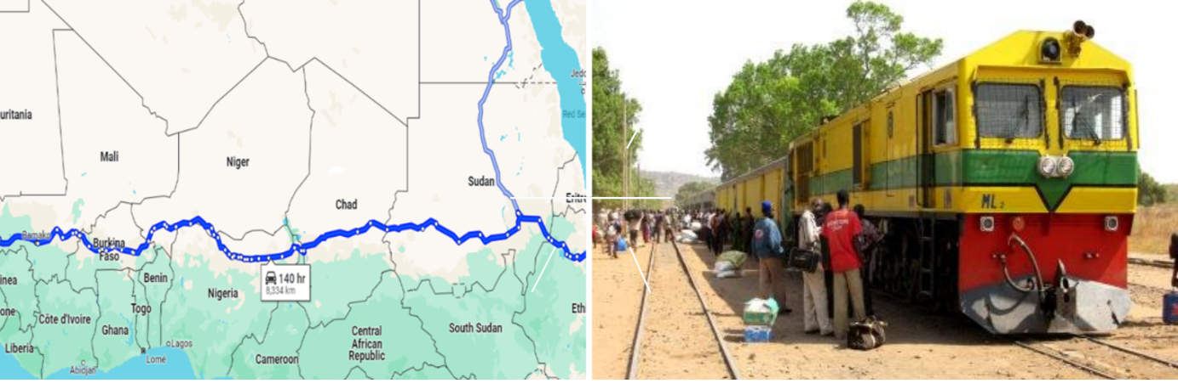
Project Status
According to 2020 project status update,the Dakar-Bamako Corridor project made significant progress in enhancing connectivity and trade between Senegal and Mali. One notable milestone in the project's progress occurred in 2020 when Mali entered into an agreement with China Railway Construction Corp to renovate a rail line connecting Bamako to the Senegal border. As the rehabilitation efforts continue, the project is expected to bring about transformative changes, improving transportation infrastructure and connectivity along the corridor. This progress not only benefits the two countries directly involved but also contributes to the broader regional development and cooperation.

Project Highlights

8500 KM of Road to be Constructed. | 400 million People to Benefit from Project. | 9 Countries to benefit from project upon completion | USD 25 billion is the estimated cost of project


SOUTH AFRICA - Lesotho Highlands Water Project – Phase II
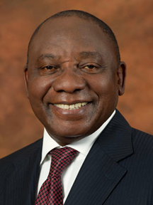
The project involves the development of the Polihali Dam, Saddle Dam, and a water transfer tunnel from Polihali Dam to Katse Dam, utilizing the waters of the Senqu/Orange River in the Lesotho highlands. The primary beneficiaries of this project are South Africa and Lesotho. The development objectives of the project are to ensure water security of the Gauteng Region of South Africa and improve the socio-economic development of Lesotho through improved infrastructure and potential for hydropower generation. The project specifically aims to increase the transfer of water from Lesotho to the Republic of South Africa from the current 780 million m3/year to 1260 million m3/year to address the growing water requirements in South Africa's major industrial and population centres providing a steady water source for its sustained growth.
H.E. President Cyril Ramaphosa
The Republic of South Africa

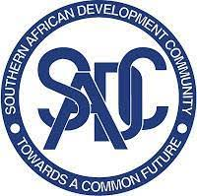
Project Status

The initiative spans a 30-year program consisting of five distinct phases. Phase I was finished in 2003 and inaugurated in 2004, while Phase II is currently underway. Construction began in May 2023 and expected to be completed by February 2031. The project stands at 19.9% completion. The variance in project schedule is due to ongoing delays on the main works and prior procurement issues. A recovery plan has been initiated, with LHDA management meeting with contractors to address mobilization delays. The total completion cost is expected to be USD 2.2 billion [ZAR 42,056,490,039.00]
Timelines
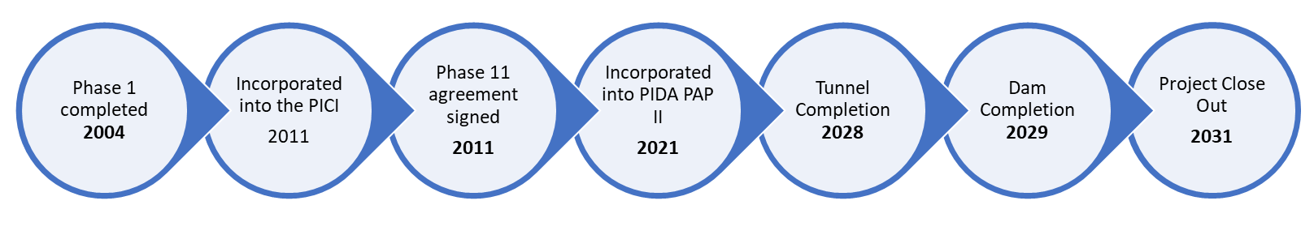

Project Highlights

 |  |  | 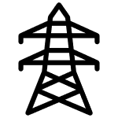
1260 million cubic meters per year | Will augment availability of water in the greater Gauteng region with a combined population of 26 million | 2 countries to benefit from project upon completion | 4MW of electricity produced and 48km of transmission lines developed

SOUTH AFRICA - Grand Inga Project
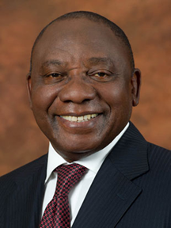
The Grand Inga project is a major hydropower initiative located in the Democratic Republic of Congo (DRC). It aims to harness the immense hydropower potential of the Congo River, specifically at the Inga Falls, to generate clean and renewable energy. The Grand Inga project is divided into several phases, with Inga III being the next phase in line. The overall objective of the project is to provide affordable and reliable electricity to meet the energy needs of the DRC and the wider African continent. The estimated cost of the Grand Inga project is more than US$80 billion, excluding the expenses for the transmission lines required to distribute the power across Africa. The project's success depends on securing local and regional creditworthy off-takers and mobilizing the necessary financial resources.
H.E. President Cyril Ramaphosa
The Republic of South Africa

Project Status
The DRC, through the Agency for Development and Promotion of the Grand Inga Project (ADPI-RDC), has demonstrated commitment to the project. The ADPI-RDC, now under new management, is facilitating administrative, financial, and technical procedures to implement the project.
In July 2023, President Ramaphosa and President Tshisekedi convened the 12th DRC-South Africa Bi-National Commission where they renewed their commitment to the project and the renewing the various legal instruments governing their cooperation.
A high-level consultation meeting was held between ADPI, AUC and AUDA-NEPAD in August 2023 at the African Union offices in Addis Ababa. The SADC Secretariat is facilitating a technical assessment meeting with partner countries identified for the first phase of the Grand Inga Hydropower project.
The Democratic Republic of Congo and the Republic of South Africa are poised to renew the off-take treaty, which was initially signed in 2013 and expired in October 2023. The SADC Secretariat is arranging for the renewal of the treaty by December 2023. Moreover, an Inter-Governmental MOU between five SADC Member States — DRC, Zambia, Zimbabwe, Botswana, and South Africa — has been developed as an alternative solution for the transmission line to evacuate power into the SADC electricity market and is awaiting signature.

Project Highlights
The project aims to achieve a total installed capacity exceeding 42,000 MW and it is expected to create more than 80,000 employment opportunities. The project's footprint spans across the regional economic communities of SADC (Southern African Development Community), ECCAS (Economic Community of Central African States), and EAC (East African Community). It impacts a total of 21 countries.


42,000 MW of new and cleaner electricity generation | 80 thousand jobs to be created from the Project. | 21 Countries to benefit from project upon completion | New Electricity transmission powerlines spanning across EAC, SADC and ECAS regional economic communities


SOUTH AFRICA - The Beitbridge Border post and related infrastructure
The Beitbridge One Stop Border Post (OSBP) project is focused on revitalizing and modernizing the border post between South Africa and Zimbabwe. Its objective is to enhance the movement of goods and people across the border while establishing the port as an efficient economic facilitator. The project is slated to be completed within three years, followed by a 20-year concession with a private entity responsible for maintaining the infrastructure. The anticipated completion date for the project is 2024/25.
H.E. President Cyril Ramaphosa
The Republic of South Africa
The related infrastructure include The North-South Rail Corridor Project which focuses on the enhancement, rehabilitation, and upgrade of the NSC railway network. This network connects the mining district of Kolwezi in the DRC to the ports of Durban and Richards Bay in South Africa.
The corridor, which spans six countries including DRC, Zambia, Zimbabwe, Botswana, South Africa, and Swaziland, is a significant regional initiative aimed at boosting trade, job creation, industrial development, and overall economic growth within the SADC region.
The NSC project comprises a rail network exceeding 4,000 km, two deep-sea ports, and several inland terminals. It involves seven rail operators, including Societe Nationale des Chemins de fer du Congo, Zambia Railways Limited, National Railways of Zimbabwe, Beitbridge Bulawayo Railways, Botswana Railways, Eswatini Railways, and Transnet. These operators aim to provide a seamless, safe, predictable, reliable, and competitive railway service.
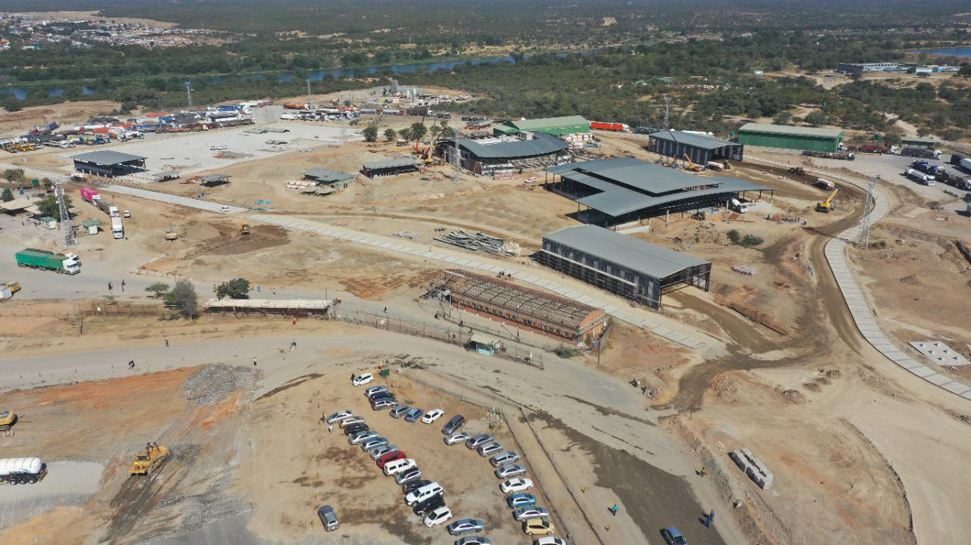
Project Status
The improvements on the Zimbabwe side of the border post (valued at US$300million) were undertaken in 3 phases from 2019 to 2022 through a PPP funded by a consortium of South African banks. The modernised Beitbridge Zimbabwe border post was inaugurated by H.E. President Emerson Mnangagwa in August 2022.
With the improvements, border processing times for trucks have significantly improved, decreasing from days to hours; with almost 500 trucks crossing daily.
On 5th October, President Ramaphosa launched South Africa’s Border Management Authority which will among other things oversee the implementation and management of the country’s one-stop border posts, including Beitbridge.
Update on Beitbridge-Harare-Chirundu Road: On November 11, 2020, the Zimbabwean government announced the completion of the first 100km of the improved Harare-Beitbridge highway. Earlier, in August 2020, President Mnangagwa of Zimbabwe stated that the Beitbridge-Harare-Chirundu Road is being upgraded to meet the SADC road infrastructure standards, including the dualization of some parts, and is expected to be fully completed by 2022.
Harare-Masvingo-Beitbridge Highway -As of December 2020,the Zimbabwean government had completed the first 100km of the 584km Harare-Masvingo-Beitbridge Highway upgrade, which will enhance travel efficiency. The state-funded project, costing US$650 million, is crucial for achieving Zimbabwe’s Vision 2030. The highway’s modernization is part of regional development programs, with five local companies working on it. Additionally, work has begun on the Makuti-Chirundu Road, financed by a US$21 million grant from Japan. Both projects aim to improve Zimbabwe’s connectivity with other African nations.
Editorial note - please note that the North-South Rail Corridor section will be updated with progress updates from the member state once they have been received.

Project Highlights

SOUTH AFRICA - South Africa to Become the Hub for the Manufacture and Supply of Rail Stock for Africa
The objective of the project is to establish Africa as a rolling stock manufacturing hub and utilize the capabilities and capacities existing in the region. The project aims to identify two classes of opportunities: competitive projects for the provision of rolling stock and services on the continent, and strategic partnerships at the government-to-government (G-to-G) level to establish a continental supply chain. Overall, the project aims to foster industrial growth, enhance competitiveness, and drive economic development in Africa's rail sector. The North-South Road, Rail, and related Infrastructure Corridor project is part of the broader efforts to promote regional integration and economic development within the Southern African Development Community (SADC). It seeks to improve the efficiency and effectiveness of transportation networks, facilitate trade, and enhance connectivity between countries.
H.E. President Cyril Ramaphosa
The Republic of South Africa

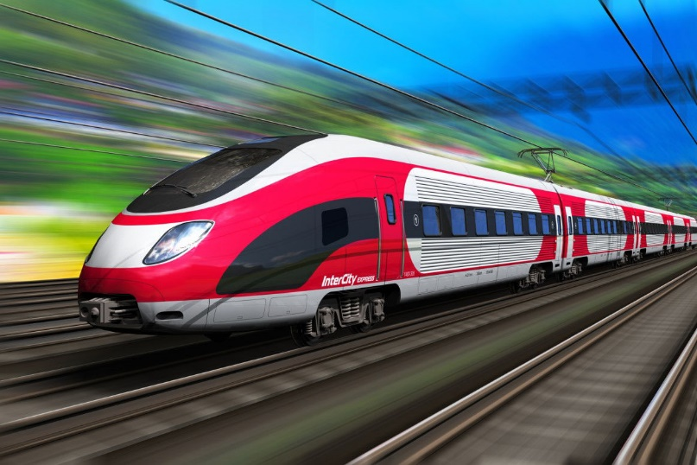
Project Status
Transnet reports that progress has been made in establishing links and cooperation with Prasa's technical team in terms of general cooperation, maintenance, research, and development, and addressing skills shortages. Additionally, efforts have been made to support the development of an industry sector strategy, engage with relevant authorities on the definition of designated items, and align the objectives of the AU Declaration, Industry Sector Strategy, and localization initiatives. The establishment of the Transnet Academy and pursuit of business opportunities on a competitive basis and G-to-G initiatives are ongoing. A feasibility study is underway to develop a business case for a sustainable African Rail Industry. The study includes economic analysis, analysis of the rolling stock supply chain, identification of issues and recommendations for PRASA's localization program, factors driving industry regeneration, and required infrastructure.
The Minister of Transport signed the Luxembourg Rail Protocol in March 2022, and it was approved by the Cabinet in June 2023.The protocol enhances private sector participation and reduces financing costs for rolling stock.
The development of Passenger Rail Manufacturing Master Plan (PRMMP) is in progress and key milestones include finalizing the scoping exercise, conducting an African market analysis, and developing a business case by December 2024.

Project Highlights
  By December 2023, 186 new trains were produced. | 1148 employed employees | All African counties to benefit

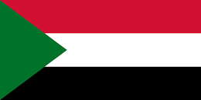
SUDAN - Sawakin, Port Sudan Project and two related infrastructure Projects

The projects aim to enhance transportation and trade capabilities in the region. The project includes the development of the Sawakin Seaport Harbour, the Dakar-N'djamena-Port Sudan Railway, and the Babanusa-South Sudan Railway. These initiatives seek to modernize port infrastructure, establish railway connections, and facilitate trade and transportation between Sudan, South Sudan, Senegal, and Chad.

Project Status
Sudan and Qatar signed a $4-billion agreement to jointly develop the port city of Suakin in north-eastern Sudan on the Red Sea coast in March 2018. The agreement was signed as both countries agreed on the necessity to boost their cooperation in the fields of transport and communications1. The project is expected to be completed by 2020 and will include a free zone and seaport infrastructure. The project aims to enhance Suakin’s operations to become the main commercial gateway in the region.

Project Highlights

400 million People to Benefit from Project.

Lessons Learned & Recommendations
High-level political support and committed institutional involvement are crucial for the development and implementation of large infrastructure projects, especially transboundary ones. This support, extended to projects under the PICI initiative, accelerates infrastructure development and assures political and governance-related risks, encouraging private sector participation. The projects, which are regional or collective flagships of the participating countries, are coordinated and monitored under regional policies, treaties, and intergovernmental agreements. These frameworks provide guidelines for infrastructure development and are demonstrated through various engagements, including the infrastructure committee and specific project engagements by heads of state and government.

PICI has demonstrated the ability to accelerate complex cross-border infrastructure projects, pointing to a number of success factors such as:
- High level political buy in and commitment
- Advocacy and high visibility resulting from championing of projects by the heads of state and government.
- Alignment of projects to national and regional frameworks and priorities
- Low perceived political and investment risk to attract private sector participation and investment.
- Strong coordination and governance mechanisms between countries

At the same time, the implementation of PIC projects points to a number of challenges:

- Delays in project implementation
- Low private sector participation
- Lack of robust data sharing mechanisms
- Lack of a tailored monitoring, evaluation and learning framework
- Political cycles that sometimes result in change in priorities and in projects stagnating
- Lingering economic and financial impacts of Covid 19 and global fragility and conflicts situation
- Fragility and conflict status in member states
- Change of focal points
- Inability to address the multiplicity of regulatory environments and lack of synergy in regulatory requirements and agencies between countries and regions

Recommendations
While there has been significant progress in the implementation of PICI, itis clear that there is room for improvement and the following are some recommendations to guide and shape the delivery of results going forward.
- Project Preparation: While the efforts of the Presidential champions are mostly aimed at “implementation” they should also focus on the important aspect of mobilising resources for project preparation.
- Climate-resilient infrastructure & financing: The concept of green, digital, inclusive infrastructure projects is on the rise, owing to concerns about climate change and its impact. PICI needs to incorporate these considerations in the identification of projects and develop mechanisms to leverage innovative and emerging sources of financing such as green bonds, climate financing etc
- Monitoring & Evaluation: Monitoring and reporting on PICI projects is of paramount importance and PICI needs to put in place the relevant mechanisms to ensure that information on projects is up-to-date and meets investor requirements. Further elaboration of this recommendation points to:
- An outcome-driven Framework: Adopt a results-based management approach.
- Data Collection: Encourage member states to use the African Infrastructure Database (AID) as a central portal for updating and storing project information.
- Analytical Review: there is a need to conduct a regular review to measure actual results against projected outcomes, identifying challenges and best practices.
- Reporting & Feedback Loop: Disseminate project insights through diverse platforms, engaging stakeholders, and ensuring a loop of continuous feedback.

- Strengthening the PICI secretariat: AUDA-NEPAD which acts as the secretariat for PICI needs to be well-resourced both technically and financially in order to provide the needed level of support for PICI. Due consideration should be given to:
- AU Budget Allocation: Dedicated budget to support the PICI Secretariat within AUDA-NEPAD
- Special Fund: Establish a dedicated fund pooling resources from various partners and sources for project preparation and technical advisory services availed by AUDA-NEPAD
- Technical staff: member states should consider seconding experts to AUDA-NEPAD to support PICI project implementation.

- Project Graduation from PICI - the PICI project pipeline should be regularly reviewed so that projects that have advanced significantly are formally recognised and allowed to graduate out of PICI to make way for new projects.

- Visibility of PICI & Accession Process: PICI should be promoted to all member states and the process of joining/accession formalized to enable more projects to benefit from the initiative.

Conclusion
The 2022-2023 Progress Report of the PICI underscores the significant advancements and challenges faced in our collective efforts towards regional infrastructure development in Africa. The PICI has been instrumental in identifying and fostering essential transnational project support pipelines across various sectors. Through strategic partnerships and stakeholder engagement, the PICI has successfully attracted investments and mobilized resources to support the implementation of some of the most crucial infrastructure projects.
To ensure its ongoing success in driving Africa’s infrastructure development ambitions, the PICI must effectively address the challenges encountered over the past 12 years since the initiative was launched. The participating countries must also work together to leverage emerging opportunities afforded by innovative financing mechanism, the promise of the African Continental Free Trade Area (AfCFTA) and the Agenda 2063 second ten year implementation plan. This will ensure that PICI continues to play its pivotal role in Africa’s infrastructure development.

Annex 1 - PICI Implementation Framework

The Mandate

The mandate of the Presidential Infrastructure Champion Initiative (PICI) is derived from the African Union (AU) and its commitment to advance regional infrastructure development thereby promoting regional trade and integration and enhance the quality of life. The initiative was conceived with the specific aim of expediting infrastructure development through the dedicated advocacy and championing of projects at the political level. This is therefore a collaborative platform that was conceptualized, developed, and is now implemented by the current champions to the initiative.

Governance
The PICI is governed by a robust framework that encompasses the Champions and Technical Experts in the various components of its structure. This structure was designed to guarantee that the PICI operates with transparency, accountability, fostering coordination, collaboration, and the effective execution of PICI projects.
South Africa holds the chairmanship at both the presidential level and the ministerial level. AUDA-NEPAD serves as the Secretariat to the PICI and co-chairs the Technical Task Team (TTT).
NEPAD HSGOC Heads of State and Government Orientation Committee (HSGOC) and AU Assembly: Established in 2010, the HSGOC provides leadership and sets policies for AUDA-NEPAD, with Heads of State and Government guiding priorities and programs of action.
- NEPAD HSGOC High-level Ad Hoc Subcommittee on Infrastructure: The High-level Ad Hoc Subcommittee on Infrastructure, made of the political champions, is part of NEPAD HSGOC. It ensures the ongoing priority of regional infrastructure development, providing political champions for specific projects and contributing to sustained momentum.
- PICI Ministerial Working Group: Chaired by South Africa, the Ministerial Working Group oversees PICI project progress, adopts reports, selects projects, and proposes champions, thus playing a pivotal role in directing PICI initiatives.
- The PICI Technical Task Team (TTT): The TTT, made of member state focal points, co-chaired by South Africa and the secretariat, supports the Ministerial Working Group by deliberating on the initiative's direction and presenting progress reports required for informed decision-making.
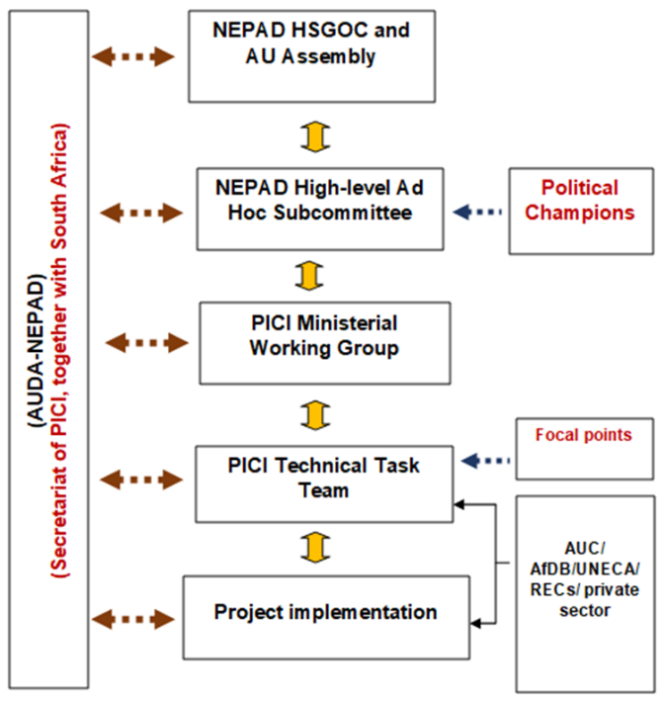
- African Union Commission: The AUC collaborates closely with AUDA-NEPAD, holds a key role in the TTT and ensures alignment of continental strategies for the preparation and implementation of PICI projects.
- Other stakeholders: The AfDB, UNECA, and RECs contribute significantly to implementation and resource mobilization from various sources including the private sector
- AUDA-NEPAD Agency: The AUDA-NEPAD Agency, the technical arm of the AU, plays a dual role. Firstly, it serves as the secretariat of PICI, coordinating stakeholders, ensuring transparency through progress reporting, and facilitating platforms for operation and reporting such as the TTT workshops and annual breakfast meetings. Secondly, it works with project sponsors and focal points to advance projects to bankability, leveraging a suite of tools and instruments developed for this purpose. Despite not having specific funding for PICI support, the Secretariat has been instrumental in ensuring the smooth functioning of PICI and providing necessary support to project champions and stakeholders over the years.

Reporting
The Presidential Infrastructure Champion Initiative (PICI) conducts an annual reporting process that integrates various stakeholders and aligns progress updates with strategic priorities. This multi-faceted process involves key entities of its structure, using both top-down and bottom-up approaches. The Secretariat of PICI ensures accountability and timely reporting by engaging stakeholders and maintaining a robust reporting mechanism.
The HSGOC and AU Assembly, while not directly involved in regular reporting, contribute to the policy framework that guides PICI. The NEPAD HSGOC High-level Ad Hoc Subcommittee on Infrastructure prioritizes regional infrastructure development.
Political champions, although primarily functioning in their political roles, provide valuable insights and strategic direction during the reporting process. Their input, supported by the Ministerial group and the Technical Task Team (TTT), helps monitor project advancements, resolve bottlenecks, and mobilize financing for project goals.
Yearly meetings are held across the continent, including 10 meetings of the Ad-hoc Committee on Infrastructure, 4 meetings of the Ministerial Working Group, and 9 meetings of the TTT since the inception of PICI. A Presidential Breakfast, hosted by the President of South Africa, serves as a reporting platform and is held before the HSGOC meetings.

Operational procedures/working methods of PICI.
The operational procedures of PICI are designed to ensure effective implementation and involve several key steps:
- Meetings: Regular meetings are held at crucial milestones such as project initiation, planning, implementation, and evaluation stages. These meetings facilitate coordination, collaboration, and informed decision-making among stakeholders.
- Progress Tracking: A robust tracking system is used to monitor the progress of projects, assess the status of each component, identify bottlenecks, and implement corrective actions.
- Reporting: Regular reporting mechanisms provide comprehensive updates on the status, achievements, and future plans of projects. These reports are essential tools for evaluating performance and informing decision-making processes.
- Stakeholder Engagement: Communication channels are established, consultations are conducted, and relevant parties are involved in decision-making processes to ensure effective stakeholder engagement.
- Risk Management: Proactive strategies are implemented to identify, assess, and mitigate potential risks. Risk assessments are conducted at various stages, and mitigation measures are integrated into project plans to minimize disruptions and enhance project resilience.
In summary, these procedures aim to ensure the successful execution of PICI projects, from initiation to completion, while engaging stakeholders and managing potential risks

Annex 2 -Countries Benefiting from PICI Projects

Table 2 Countries Benefiting from PICI Projects
Country | No. of PICI  Projects | Projects
Algeria | 3 | The Missing Links of The Trans-Sahara Highway  Fibre Optic Link Between Algeria and Nigeria Via Niger;  The Nigeria-Algeria Gas Pipeline Project (Trans-Sahara Gas Pipeline- TSGP)
Angola | 1 | The Namibia-International Logistics Hub
Benin | 1 | Abidjan-Lagos Corridor Project
Botswana | 1 | The Namibia-International Logistics Hub
Burkina Faso | 1 | Dakar-Bamako (Dakar – Ndjamena – Djibouti) Corridor Project
Burundi | 1 | Construction Of Navigational Line Between Lake Victoria and The Mediterranean Sea
Cameroon | 1 | Dakar-Bamako (Dakar – Ndjamena – Djibouti) Corridor Project
Chad | 4 | The Missing Links Of The Trans-Sahara Highway; Fiber Optic Link Between Algeria And Nigeria Via Niger, The Nigeria-Algeria Gas Pipeline Project (Trans-Sahara Gas Pipeline- TSGP)
Côte d'Ivoire | 1 | Abidjan-Lagos Corridor Project
Democratic Republic of Congo | 2 | Kinshasa-Brazzaville Bridge Corridor Project
Egypt | 1 | Construction Of Navigational Line Between Lake Victoria and The Mediterranean Sea
Eritrea | 1 | The North South Road, Rail Corridor and Related Infrastructure
eEthiopia | 3 | Construction Of Navigational Line Between Lake Victoria and The Mediterranean Sea; The Lamu Port - South Sudan – Ethiopia Transport Corridor (LAPSSET) Project
Federal Democratic Republic of Ethiopia | 1 | The Lamu Port - South Sudan – Ethiopia Transport Corridor (LAPSSET) Project
Gabon | 1 | The North South Road, Rail Andand Related Infrastructure Corridor
Ghana | 1 | Abidjan-Lagos Corridor Project
Kenya | 3 | Construction Of Navigational Line Between Lake Victoria and The Mediterranean Sea; The Lamu Port - South Sudan – Ethiopia Transport Corridor (Lapsset) Project
Lesotho | 1 | Lesotho Highlands Water Project – Phase II
Libya | 1 | The North South Road, Rail Corridor and Related Infrastructure
Malawi | 1 | The Namibia-International Logistics Hub
Mali | 2 | The Missing Links Of The Trans-Sahara Highway; The Optic Fibre From Algeria Via Niger To Nigeria
Morocco | 1 | The North South Road, Rail and Related Infrastructure Corridor
Namibia | 1 | The Namibia-International Logistics Hub
Niger | 5 | The Missing Links of The Trans-Sahara Highway And The Optic Fibre From Algeria Via Niger To Nigeria; Fiber Optic Link Between Algeria and Nigeria Via Niger;The Nigeria-Algeria Gas Pipeline Project (Trans-Sahara Gas Pipeline- TSGP)
Nigeria | 6 | The Missing Links of The Trans-Sahara Highway; The Optic Fibre from Algeria Via Niger To Nigeria; Fiber Optic Link Between Algeria and Nigeria Via Niger;The Nigeria-Algeria Gas Pipeline Project (Trans-Sahara Gas Pipeline- TSGP); Abidjan-Lagos Corridor Project
Republic of Congo | 1 | Kinshasa-Brazzaville Bridge Corridor Project
Republic of Kenya | 1 | The Lamu Port - South Sudan – Ethiopia Transport Corridor (LAPSSET) Project
Republic of South Sudan | 1 | The Lamu Port - South Sudan – Ethiopia Transport Corridor (LAPSSET) Project
Rwanda | 1 | Unblocking Political Bottlenecks for ICT Broadband And Optic Fibre Projects Linking Neighbouring Countries
Senegal | 1 | Dakar-Bamako (Dakar – Ndjamena – Djibouti) Corridor Project
South Africa | 1 | The North South Road, Rail Corridor and Related Infrastructure
South Sudan | 2 | Construction of Navigational Line Between Lake Victoria and The Mediterranean Sea; The Lamu Port - South Sudan – Ethiopia Transport Corridor (LAPSSET) Project
Sudan | 3 | Construction of Navigational Line Between Lake Victoria and The Mediterranean Sea, The Lamu Port - South Sudan – Ethiopia Transport Corridor (Lapsset) Project
Tanzania | 2 | Construction of Navigational Line Between Lake Victoria and The Mediterranean Sea; The Lamu Port - South Sudan – Ethiopia Transport Corridor (LAPSSET) Project
Togo | 1 | Abidjan-Lagos Corridor Project
Tunisia | 2 | The Missing Links of The Trans-Sahara Highway; The Optic Fibre From Algeria Via Niger To Nigeria
Uganda | 1 | Construction of Navigational Line Between Lake Victoria And The Mediterranean Sea
Zambia | 1 | The Namibia-International Logistics Hub
Zimbabwe | 1 | The North South Road, Rail Corridor and Related Infrastructure

